**Ex:no:3**

**Date:23\3\25**

**3.Write a servlet program that prints “Hello, World!” when accessed through a browser.**

**Aim:**

To Write a servlet program that prints “Hello, World!” when accessed through a browser using java.

**Program:**

**Helloworld.java:**

package com.muthulakshmi.servlet;

import java.io.IOException;

import java.io.PrintWriter;

import javax.servlet.ServletException;

import javax.servlet.annotation.WebServlet;

import javax.servlet.http.HttpServlet;

import javax.servlet.http.HttpServletRequest;

import javax.servlet.http.HttpServletResponse;

/**

* Servlet implementation class Helloworld

*/

@WebServlet("/Helloworld")

public class Helloworld extends HttpServlet {

private static final long serialVersionUID = 1L;

/**

* @see HttpServlet#HttpServlet()

*/

public Helloworld() {

super();

// TODO Auto-generated constructor stub

}

/**

* @see HttpServlet#doGet(HttpServletRequest request, HttpServletResponse response)

*/

protected void doGet(HttpServletRequest request, HttpServletResponse response) throws ServletException, IOException {

PrintWriter p=response.getWriter();

p.println("hello world");

}

/**

* @see HttpServlet#doPost(HttpServletRequest request, HttpServletResponse response)

*/

protected void doPost(HttpServletRequest request, HttpServletResponse response) throws ServletException, IOException {

// TODO Auto-generated method stub

doGet(request, response);

}

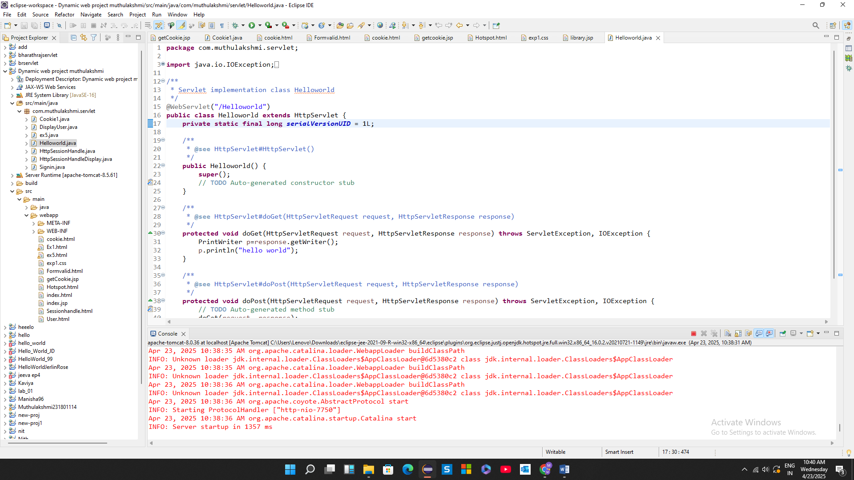

**OUTPUT:**

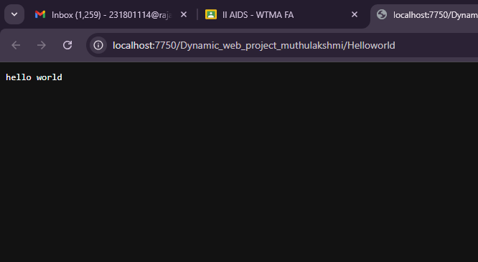

**Result:**

Thus the servlet hello world program was executed successfully on web browser.